Tenant Services Measures – Supporting information

The Regulator of Social Housing requires all registered providers to generate and report Tenant Satisfaction Measures (TSMs) yearly as part of the Consumer Standards framework.
These measures combine data generated from internal management information with data derived from perception surveys. This combined data will enable customers to scrutinise their landlord's performance effectively. The surveys were required to be undertaken between 01 April 2024 and 31 March 2025, with the formal submission of results required by 30 June 2025.

A) Summary Of Achieved Sample Size
Unity has 1364 LCRA households and to meet the requirements, has to provide data with an overall accuracy of ±5% at the 95% confidence interval for the Tenant survey.
At the end of data collection, a total of 362 responses had been collected. This meets the requirements set by the Regulator and supplies data with overall accuracy of ±3.8% for TP01, allowing for accurate breakdowns of the results into subgroups.

B) Timing Of The Survey
Unity opted to carry out the survey interviews between November 2024 and March 2025.

C) Data Collection Methods
The survey was undertaken by telephone as this is a cost effective and efficient means of contacting households and allows the representativeness of the achieved sample to be easily monitored and controlled.
Kwest’s interviewers worked in shifts to provide maximum coverage. Telephone calls were made at different times of the day, including morning, afternoon and evening attempts and weekend calls were available. Interviewers made up to 5 attempts to secure a survey response with each sampled LCRA household.
To comply with the guidelines issued by the Regulator of Social Housing, the results excluded tenants of certain property types such as leaseholders, shared ownership and non-social housing
D) Sampling Methods
A stratified sampling method was used, taking into a number of criteria, including age, property type, and region.

E) Assessment Of Representativeness Of Respondents
The statistical accuracy achieved in the survey will ensure excellent representativeness of response. Kwest’s in-house software team has developed bespoke resources that allow representativeness to be monitored and achieved. Representativeness is checked and monitored against a range of criteria. For example; Kwest’s sophisticated Telephone Management systems are designed so that quotas for multiple, individual groups of interest can be automatically set, managed and monitored simultaneously to deliver required accuracy levels and excellent representativeness. As one quota is completed, contact details are withdrawn from that group and other live groups continue to be prioritised.
Kwest’s TSM Representativeness Assessment ensures that the stringent requirements of the Regulator are adhered to in TSM surveys. Our dashboards work in conjunction with the Telephone Management System and provide an adaptive, flexible tool for monitoring and adjusting interviewing approach throughout the survey, to ensure that the achieved sample perfectly matches the base population. Output on Kwest’s online reports allowed Unity to view progress versus targets at any time throughout the project.
To demonstrate representativeness of response, Kwest use a number of population sub-groups taken from data held by Unity. These include age, gender, asethnic group, property type, and household size. Due to the adaptive and flexible nature of our systems and the ability to continually adjust interviewing throughout data collection, representativeness is an excellent match across all groups assessed. Details of this are provided below.
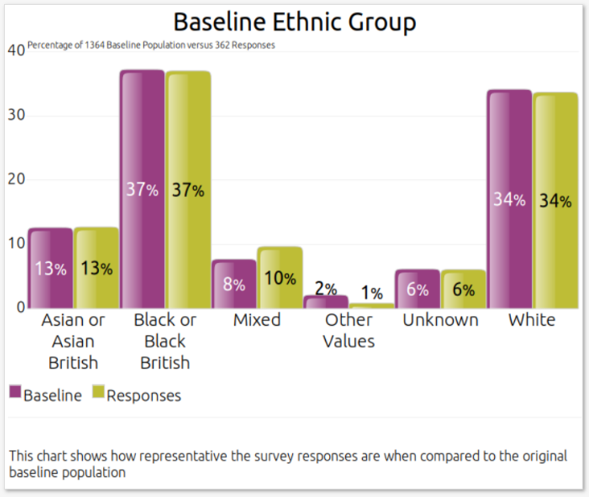
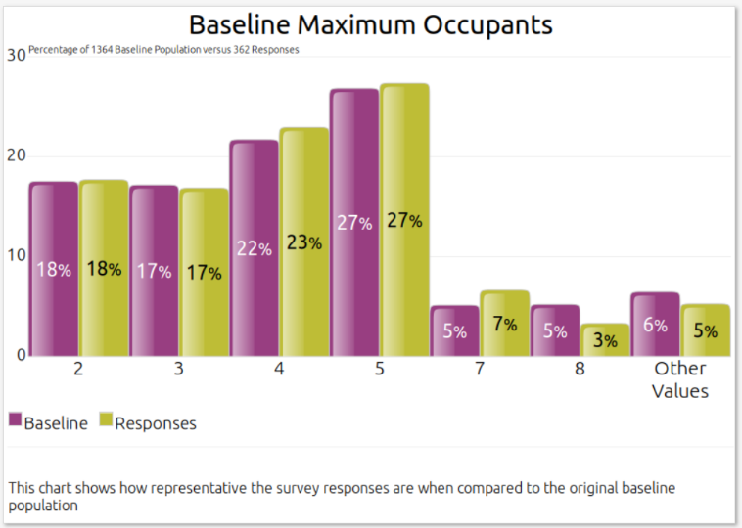
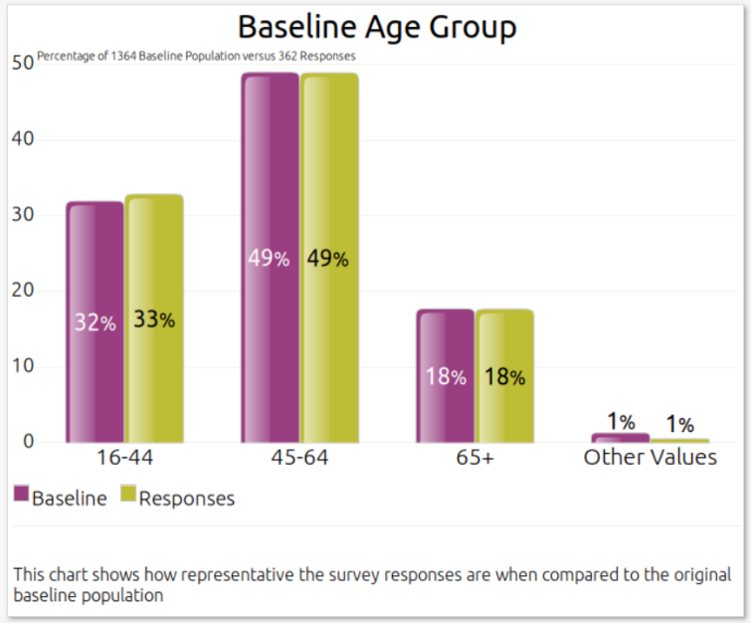
The full TSM Representativeness Assessment is as follows:
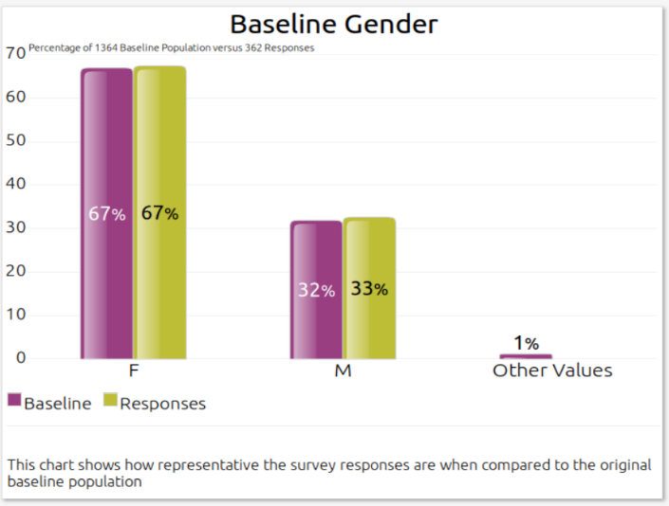

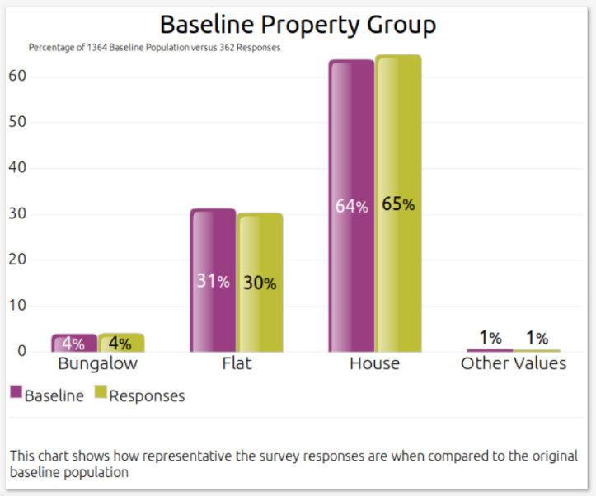

F) Details Of Applied Weighting
Not applicable. Due to the tools used to monitor response throughout data collection and the Kwest TSM Representativeness Assessment, excellent representativeness was achieved across multiple groups and therefore no weighting of data was required.

I) Reasons For Failure To Meet Required Sample Size Requirements
Not applicable, a sufficient number of responses have been gathered to meet the requirements.

J) Incentives Used In The Survey To Encourage Response
Not applicable, a sufficient number of responses have been gathered to meet the requirements.

K) Methodological Issues That Have A Material Impact On Satisfaction
There are no methodological issues that have a material impact on the tenant perception measures reported.

